Name: ________________________________ K5 Summer Reading Log
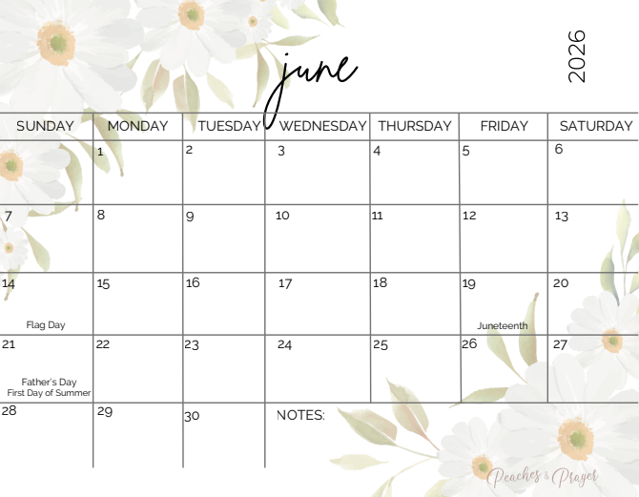

Please read aloud 5 days a week, for 20 minutes each day with your child.
Color in the dates that you read and return the calendar the first week of school.
Name: ________________________________ K5 Summer Reading Log
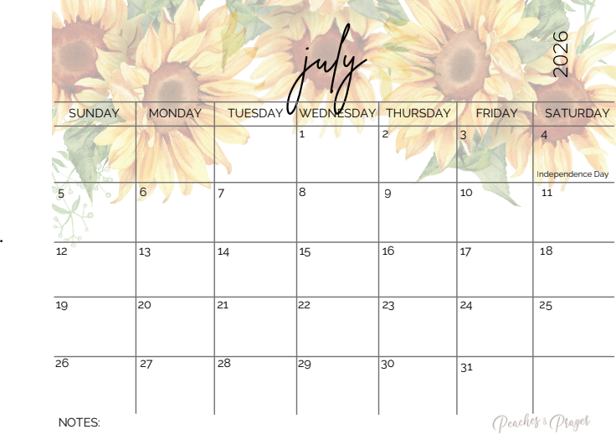

Please read aloud 5 days a week, for 20 minutes each day with your child.
Color in the dates that you read and return the calendar the first week of school.
Name: ________________________________ K5 Summer Reading Log
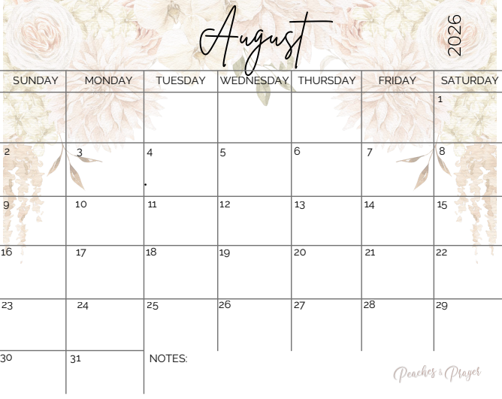

Please read aloud 5 days a week, for 20 minutes each day with your child.
Color in the dates that you read and return the calendar the first week of school.

