Name: ________________________________ First Grade Summer Reading Log
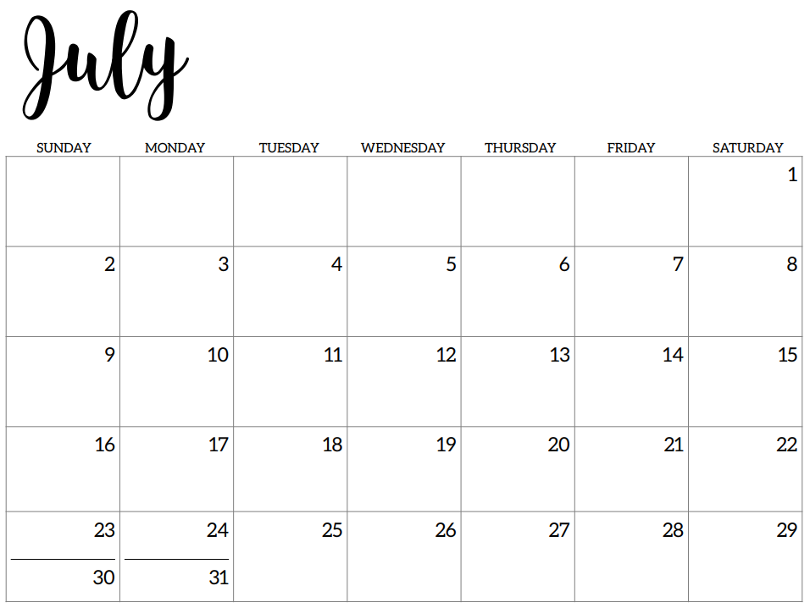
Please read aloud 5 days a week, for 20 minutes each day with your child.
Color in the dates that you read and return the calendar on August 3rd.

